Options for engaging in Analysis (DTM and Partners, Clusters, WGs and AoRs)
This summary is adapted from on Okular Analytics report for DTM and includes results by the Grand Bargain Work Stream on Joint Needs Assessments

Levels of Analysis
Analysis generally refers to the organized process of transforming raw data into actionable insights, for better decision making.
The goal of analysis in humanitarian crisis is to estimate or provide informed opinions about critical gaps and their potential and confirmed humanitarian consequences. This includes a systematic set of procedures, undertaken for the purposes of setting priorities, based on severity of current conditions or the risks faced by the affected population. It is an iterative process aimed at making sense of data. It continues until it is possible to draw conclusions that answer the original questions, with a reasonable degree of certainty.
Most forms of analysis can be described as levels, where one builds on another, each increasing the understanding of the findings and revealing progressively what the data means, what may happen next and what could or should be done about it. Six levels are commonly used for data analysis, represented in the following diagram.

Each analytical level entails different activities and require different combinations of competencies AND interaction with experts:
- Exploratory analysis: The analysis team assess geographical coverage, available and unavailable data, correct errors and prepare for further analysis. Potential “stories” that will need further investigation are identified;
- Descriptive analysis: The analysis team summarize and consolidate key variables and observations and prepare results using pre-identified analysis plan. Main patterns, trends, anomalies and outliers are identified;
- Explanatory analysis: The analysis team, in consultation with experts, identifies main underlying mechanisms/processes/factors that contribute to current gaps;
- Interpretive analysis: The analysis team, in consultation with experts, discuss and establish critical gaps, set priority geographical areas and affected groups and assess uncertainty and information gaps;
- Anticipatory analysis: Based on risk analysis and possible scenario, the analysis team, in consultation with experts, discuss and establish future potential gaps and refine the list of priority geographical areas or affected groups;
- Prescriptive analysis: The analysis team, in consultation with experts, discuss and agree on a strategy and objectives to change or prevent humanitarian outcomes and recommend a set of appropriate and proportionate response options (this process is also called response analysis). They define the activities and resources required to achieve the objectives (Response planning).

The analysis spectrum, adapted from Pherson and ACAPS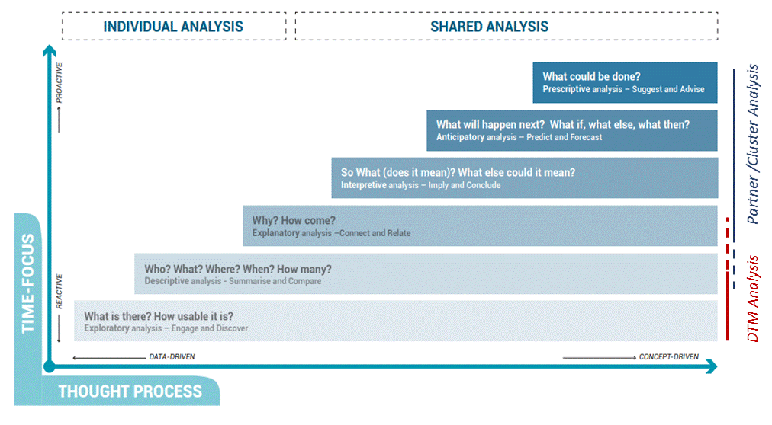

Analysist and Information management skillsets are mostly used for explanatory and descriptive analysis. Interpretive, anticipatory and prescriptive analysis require the involvement of sector specialists and cultural experts who have a sound knowledge of context and programme design in the country.

Involving decision-makers in analysis is also crucial, to ensure decision makers receive answers to their questions, and that the information and its limitations are correctly understood.

As partners /clusters move beyond a mere description of the data to a better interpretation, more collaboration and consultation is required.

Agreeing on roles for Analysis - DTM and Partners

- It is crucial that DTM and Partners agree from planning phase on whether DTM will only share data or also some type of descriptive analysis, as well as the modalities (public/restricted) and frequency of that sharing.
- It is also important that DTM and partners agree in advance (e.g., though the Data Analysis Plan) on how results should be aggregated and analysed by DTM (what descriptive analysis the cluster wants).
- Field experience consistently highlights the effectiveness of targeted presentations of results by DTM to Inter-Cluster/Sector or Sectoral/Cluster Groups. This is useful as few people have the time to read whole reports and presentations of results can be very effective in supporting accurate interpretation by subject-matter experts, cultural/context experts and decision makers (e.g., in a cluster meeting).

Options for Analysis
Several options exist for DTM and Partners, Clusters, WGs and AoRs to engage in analysis. A clear agreement on expectations, responsibilities and the degree of involvement of each actor needs to be reached in the planning phase.

Key considerations include in-country DTM and partners resources and the availability of facilitation skills. The time required to support partners’ analysis through presentations and descriptive analysis should not be underestimated and be factored in the final decision, especially if DTM is to keep its high production cycle.

A (non-exhaustive) list of such options is presented here to facilitate discussion and agreement among DTM and country level partners, Clusters and WGs. New modalities can also result from mixing elements of the listed option.

Option 1: DTM provides only raw data. Partners IM colleagues use DTM data for their exploratory and descriptive analysis. A good understanding by partners’ IM colleagues of how the data was collected is crucial for accurate analysis. These colleagues have the responsibility to explain key components of the methodology when they present results to their colleagues for interpretation, prescriptive analysis and response planning.
Option 1: DTM provides only raw data

Option 2: DTM provides raw data and descriptive analysis to partners, as agreed in the Data Analysis Plan. DTM presents results to partner in meeting (e.g., ad hoc/cluster/AoR/WG meeting). DTM has the responsibility to explain key components of the methodology when presenting results to partner. Partner uses presentation as starting point for their interpretation, prescriptive analysis and response planning. DTM can use main messages produced by partner in their narrative DTM report. Such meeting may also provide feedback on additional information need, or information no longer needed. This feedback could be used by DTM to revise questionnaire.

Option 2: DTM presents data and agreed descriptive analysis (charts, tables, maps…) to partner for their sectoral analysis

Option 3: DTM provides raw data and descriptive analysis to all partners, as agreed in the Data Analysis Plan. DTM presents results to all partners in inter-sector /cluster meeting (e.g., ad hoc/Inter-cluster WG meeting, Inter-Sector WG meeting, IMWG, Needs Assessment Working Group). DTM has the responsibility to explain key components of the methodology when presenting results to partners. Partners use presentation as starting point for their sectoral and inter-sectoral interpretation, prescriptive analysis and response planning. DTM can use main messages produced by partners in their narrative DTM report. Such meeting may also provide feedback on additional information need, or information no longer needed. This feedback could be used by DTM to revise questionnaire.
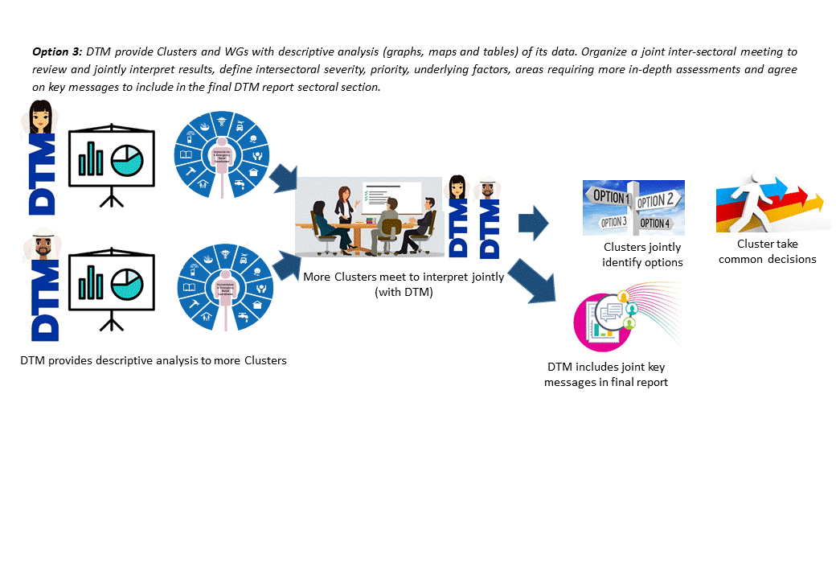
Option 3: DTM presents data and agreed descriptive analysis to all partners together for sectoral and inter-sectoral analysis

When presenting to an existing inter-sector group meeting, DTM should check that all relevant partners are invited, including, for example, sub-clusters.

