WHAT
 | Direct observation provides a snapshot picture of an affected location. |  | Both direct observation and key informant interviews can be carried out quickly and with relatively few resources during an emergency.
 | Key informant interviews provide information on critical aspects of community life and meaningful indications about access, risks, priorities, vulnerabilities and capacities at the community level. |  | Useful resource persons (Key Informants) in Bangladesh may include:  UNOs, PIOs, other Upazila officials, Union Chairmen, Union secretaries, local leaders, , police, staff of I/NGOs or the UN , religious leaders, , health workers, teachers etc
WHEN
Phases1 and 2  (approximate time frame) | 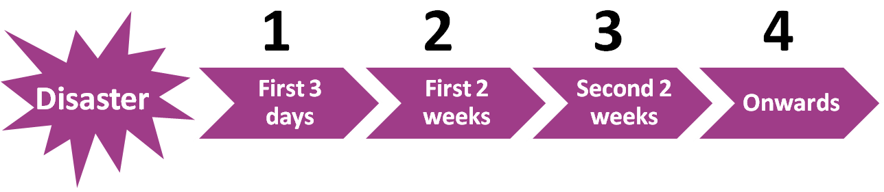 |  | Both methods are typically used together during primary field data collection (phases 1 and 2) for maximum utility.
OBJECTIVE
 | Both methods combined can provide indications related to the following key questions:  - WHAT are the key issues (sector/subsectors) and priorities?  - WHO is most affected or vulnerable?  - HOW MANY are they?  - WHERE they are?  - HOW BAD/SEVERE are the issues?  - WHY is it that way? |  | During direct observation and key informant interviews, take the opportunity to observe with an open mind, compare as much as possible, but restrict the information gathering to what can be processed, condensed and analysed within the field assessment time frame. Key questions to keep in mind::  - What has changed over time and/or remained the same?  - What is surprising, important, different about one group, one time, one place when compared to another?  - If it didn’t get worse, why not? If it will get worse, what will make that happen?  - What’s the next level of detail required?

DIRECT OBSERVATION |  | KEY INFORMANT INTERVIEWS
KEY SITES FOR OBSERVATION |  | WHO
Observe (see, smell and hear)conditionsand particular features of an affected community from a range of viewpoints and places to provide a representative view of the affected area. Walk across the community outside of predefined routes such as roads, paths or natural boundaries to obtain a cross-section of points for observation and provide a balanced view of conditions.  Look around and talk with people. Look at what is there, what is not there and what should be there:  - Observe water collection points, latrines, communal washing areas, schools, storage facilities, tea shops, cemeteries, markets, health facilities and religious centres  - In markets, see what people buy and sell as well as what the prices are for basic commodities |  | Arrange interviews with individuals of different background, responsibilities, genders, ages, and religious and/or ethnic minorities to ensure a full picture of the affected community.  The poorest and most socially excluded people in the affected community are likely to be worst hit by the crisis. Do not rely only on information from official sources and those in power as they do not always represent excluded groups in their communities.  Where an affected community includes different population groups, such as a host population and a displaced population, key informants should be selected from all groups of interest. Conduct Interviews (using tools and measurement that can be compared) at each group level.
LOOK/SEE |  | HOW
- How people relate to one another, especially in light of age, gender, disability, and other minority status  - People’s physical condition and activities. Look specifically at children, older persons, the chronically ill, and those persons with disabilities  - Conditions of housing, properties, livestock, assets, etc  - The daily lives and/or difficulties faced by women and other minorities (where and when culturally appropriate)  - State and functioning of public services, sanitation systems, and infrastructure (e.g. schools, water points, health posts etc.)  - Whether people from different groups have different coping mechanisms or access to aid  - Existing or potential public health risks in public places (waste, pollution etc)  - Power relationships and potential tensions within the community  - How differently certain segments of the population are affected or vulnerable compared to some others, and why |  | - Ask permission to carry out the interview, ensure informed consent  - Ask permission to take notes or use a PDA to record the interview. When using electronic devices, explain what it is and how it works  - Make sure the data collection instrument has space for capturing direct observation comments and notes to verify information and correct inconsistencies  - Be sensitive to the time needed to complete the interview  - Triangulate information from multiple key informants  - Record metadata (such as date, location of interview, social role of interviewee, group represented by the interviewee, contacts etc.) for each KI, as this information will be used during the analysis and interpretation of the data  - Do not ask questions that may stigmatise people or endanger them.  - Do not induce particular answers by helping an interviewee to respond or have a translator answer on behalf of a key informants
RECOMMENDATIONS |  | RECOMMENDATIONS
- Collect data without pre-conceived notions or expectations.  - Be active in observations, use all senses to gather impressions  - Record information using organised checklists to enable comparison between sites  - Note the absence of services/infrastructure and findings which contradict expectations  - Respect local culture and gender dynamics; dress, behave, and communicate respectfully  - Be sensitive to local concerns and the impact of the disaster  - Be aware of capacities, opportunities, and social capital within the visited community.  - Ask permission to take photos and/or ask questions  - Be careful, as in natural disasters a range of physical risks such as water, debris and other hazards may be present. |  | - Interview people in a safe place that is convenient to them and adapt to their needs  - Choose key informants well strategically, match information needs with likely key informants sources  - Make sure the key informants are not compromised in participating in an individual interview. Explain to community observers why the specific key informant was chosen and what topic you want to discuss  - Ensure people do not expect preferential humanitarian support in lieu of participation  - Ensure the anonymity of the data collected. If key protection risks are observed or reported by KIs, refer them confidentially to the most appropriate authorities or agency (police, Protection Cluster colleagues etc.) for confidential follow up

